

A CAPSTONE PROJECT REPORT
Submitted in the partial fulfillment for the award of the degree of
Bachelor Of Engineering
In
Computer Science and Engineering
SATELLITE MISSION PLANNING &
GROUND STATION MANAGEMENT SYSTEM
Module 3 — Communication, Data & Monitoring
CSA0911 – Java Programming
Submitted by
B. Hemanth Kumar (192324238)
Under the Supervision of
Dr. R. Thalapathi Rajasekaran

SIMATS ENGINEERING
Saveetha Institute of Medical and Technical Sciences
Chennai – 602105
SEPTEMBER 2026

SIMATS ENGINEERING
Saveetha Institute of Medical and Technical Sciences
Chennai – 602105
This is to certify that the Capstone Project entitled “Satellite Mission Planning & Ground Station Management System” has been carried out by P. Venkata Sai Pradeep Reddy (192311364), B. Hemanth Kumar (192324238) and A. Vamsi (192372242) under the supervision of Dr. R. Thalapathi Rajasekaran and is submitted in partial fulfilment of the requirements for the CSA0911 – Java Programming course in the Bachelor of Engineering in Computer Science and Engineering programme at Saveetha Institute of Medical and Technical Sciences, Chennai.

COURSE COORDINATOR | SUPERVISOR
Dr. G. Charlyn Pushpa Latha | Dr. R. Thalapathi Rajasekaran
Department of CSE | Department of CSE
Saveetha School of Engineering | Saveetha School of Engineering
SIMATS | SIMATS

INTERNAL EXAMINER EXTERNAL EXAMINER

SIMATS ENGINEERING
Saveetha Institute of Medical and Technical Sciences
Chennai-602105
DECLARATION
We, P. Venkata Sai Pradeep Reddy, B. Hemanth Kumar and A. Vamsi of the Department of Computer Science and Engineering, SIMATS Engineering, Saveetha Institute of Medical and Technical Sciences, Chennai, hereby declare that the Capstone Project Work entitled “Satellite Mission Planning & Ground Station Management System” is the result of our own bonafide efforts. To the best of our knowledge, the work presented herein is original, accurate, and has been carried out in accordance with the principles of engineering ethics and academic integrity. All sources, references, data, and other materials used in the project have been appropriately acknowledged. We further declare that the data, results, analysis, and findings presented in this report have not been fabricated, falsified, or manipulated. Any external tools, software, datasets, computational resources, or AI-assisted tools used during the project have been appropriately disclosed. We confirm that applicable ethical, academic, institutional, and professional requirements have been followed throughout the planning, execution, analysis, and documentation of the project.

Place: Chennai
Date:26/08/2026
Signature of the Students with Names

Saveetha Institute of Medical and Technical Sciences
Chennai-602105
INDIVIDUAL CONTRIBUTION STATEMENT
Student Name / Register No. | Specific Responsibilities | Design & Development Contribution | Testing & Analysis Contribution | Report Contribution | Approx. Contribution (%)
P. Venkata Sai Pradeep Reddy (192311364) | Module-level project development and integration responsibilities documented in the project report. | Mission-planning/orbit and system integration work as documented. | Validation of integrated workflow and project testing. | Technical sections and project documentation. | 33%
B. Hemanth Kumar (192324238) | Project demonstration, presentation support and integrated system responsibilities. | Support for system implementation and demonstration. | Demonstration and verification of project workflow. | Report preparation and presentation material. | 34%
A. Vamsi (192372242) | Ground-station/resource and monitoring-related responsibilities documented in the project report. | Ground-station, scheduling/monitoring integration work. | Conflict-resolution and monitoring validation. | Technical documentation and project presentation. | 33%

Total Contribution: 100%
ABSTRACT
Satellite missions depend on short and time-sensitive communication opportunities between orbiting spacecraft and ground stations. A low-Earth-orbit satellite may be visible to a particular station for only a limited period during each pass. As the number of satellites and missions increases, manual planning becomes difficult because several satellites may request the same antenna during overlapping visibility windows.
The proposed Satellite Mission Planning & Ground Station Management System is a full-stack application that integrates orbital prediction, ground-station resource management, scheduling, and real-time mission monitoring in a single platform. Satellite Two-Line Element (TLE) data is accepted as the orbital input, and an SGP4/SDP4 propagation engine is used to calculate satellite position and visibility relative to a selected ground station. From these calculations, the system derives Acquisition of Signal (AOS), Loss of Signal (LOS), elevation, azimuth, and pass duration.
The predicted Pass records are passed directly to the ground-station management module. The system checks overlapping requests, considers station and antenna capability, and applies priority-based or interval-scheduling logic to resolve conflicts. The resulting schedule becomes the input to the monitoring module, where active passes, simulated telemetry, ground tracks, alerts, and mission reports are presented through an operator dashboard.
The application follows a three-tier architecture: React + Vite + TypeScript on the frontend, Java Spring Boot on the backend, and PostgreSQL as the shared persistence layer. REST APIs support registration, queries, scheduling, and reporting, while Spring WebSocket/STOMP provides real-time tracking and telemetry updates. The project demonstrates the integration of orbital mechanics, Java enterprise development, database management, scheduling algorithms, visualization, and real-time communication into one end-to-end mission-management system.
Keywords: Satellite mission planning, ground station, SGP4/SDP4, scheduling, Spring Boot, WebSocket

TABLE OF CONTENTS

Sl.  No | TITLE | PAGE  NO
I | CERTIFICATE FROM THE SUPERVISOR | II
II | DECLARATION BY THE CANDIDATE | III
III | INDIVIDUAL CONTRIBUTION STATEMENT | IV
IV | ABSTRACT | V
V | LIST OF FIGURES | VI
VI | LIST OF TABLES | VII
VII | LIST OF ABBREVIATIONS | VIII
1 | CHAPTER 1: Introduction
2 | CHAPTER 2: Literature Review
3 | CHAPTER 3: Engineering Design & Trade-offs, Sustainability,  Ethics, Safety, Risk & Security
4 | CHAPTER 4: Implementation, Testing & Results, Project  Management
5 | CHAPTER 5: Conclusion & Reflection
 | References
 | Appendices

LIST OF FIGURES
Figure No. | Figure Name | Page No.
Figure 1 | Three-Tier System Architecture
Figure 2 | End-to-End Mission Planning Workflow
Figure 3 | Module Integration and Scheduling Flow

LIST OF TABLES
Table No. | Table Name | Page No.
Table 1 | Functional and Non-Functional Requirements
Table 2 | Functional Modules and Their Purposes
Table 3 | Technology Stack and Purpose
Table 4 | Core Entities and Stored Information
Table 5 | Scheduling Conflict Examples
Table 6 | Validation and Demonstration Test Cases
Table 7 | Module Integration and Data Flow
Table 8 | API Groups
Table 9 | Implementation Tools and Purpose
Table 10 | Project Roles and Contribution

LIST OF ABBREVIATIONS / SYMBOLS
Symbol | Description | Unit
TLE | Two-Line Element | —
SGP4 | Simplified General Perturbations 4 | —
SDP4 | Simplified Deep-space Perturbations 4 | —
AOS | Acquisition of Signal | Time
LOS | Loss of Signal | Time
REST | Representational State Transfer | —
JPA | Java Persistence API | —
STOMP | Simple Text Oriented Messaging Protocol | —

CHAPTER 1: INTRODUCTION AND ENGINEERING PROBLEM

1.1 Background
Satellite communication with Earth is constrained by orbital motion. A satellite is not continuously visible from every ground station; instead, it enters and leaves the station's visibility region as it moves along its orbit. For a typical low-Earth-orbit mission, a satellite can complete an orbit in roughly 90 minutes, while a particular ground station may observe it for only a short pass.

1.2 Need for the Project
When several missions use the same ground station, pass windows can overlap. A manually prepared schedule may therefore create conflicts, unused antenna capacity, missed communication opportunities, or inefficient allocation of station resources. A software system that predicts passes and automatically evaluates scheduling constraints can provide a more consistent planning process.

1.3 Problem Statement
The engineering problem is to integrate time-dependent satellite visibility prediction with limited ground-station resources and real-time monitoring so that candidate communication windows can be converted into conflict-aware schedules and then tracked through a single operational workflow.

1.4 Project Aim
To develop an integrated Satellite Mission Planning & Ground Station Management System that predicts satellite visibility windows, manages ground-station resources, resolves scheduling conflicts, and provides real-time mission monitoring.

1.5 Project Objectives
- To accurately compute satellite visibility windows from TLE data using SGP4/SDP4 propagation.
- To calculate AOS, LOS, elevation, azimuth, and pass duration for a selected ground station.
- To register satellites, missions, ground stations, antennas, and availability information.
- To detect overlapping pass requests and resolve ground-station scheduling conflicts using priority-based and/or interval-scheduling logic.
- To provide a real-time dashboard for active passes, simulated telemetry, alerts, maps, and mission history.
- To store shared operational data in PostgreSQL and expose functionality through a Spring Boot backend.
- To use WebSockets/STOMP to push live tracking and telemetry updates to the React frontend.

1.6 Scope
- TLE-based satellite registration and orbit propagation.
- Ground-station registration with location, elevation limits, and antenna capabilities.
- Pass prediction and storage of AOS/LOS and related visibility information.
- Availability management and conflict logging.
- Priority-based and interval-scheduling conflict resolution.
- Real-time pass tracking and simulated telemetry.
- Ground-track and polar-plot visualization.
- Historical reporting and station-utilization statistics.
- Conflict and missed-pass alerts.
- REST and WebSocket integration across a single backend.
The project is intended as an academic capstone implementation. Operational spacecraft control, certified flight dynamics, safety-critical command uplink, and production-grade mission assurance are outside the project scope. The real-time telemetry described in the report is simulated unless connected to an actual telemetry source.

1.7 Expected Engineering Outcome
The intended outcome is a working academic prototype that combines orbital prediction, resource management, scheduling, persistent data management, visualization, alerts, and event-driven monitoring into one coherent mission-management workflow.

CHAPTER 2: LITERATURE REVIEW AND EXISTING SOLUTIONS

2.1 Review Method
The project report's reference list covers research on TLE propagation accuracy, SGP4 orbit propagation, satellite range scheduling, resource-constrained scheduling, visibility conflict optimization, and genetic-algorithm-based scheduling. These references were used as the documented research basis for the project's orbit-prediction and scheduling concepts.

2.2 Review of Existing Work
The cited literature includes work on propagation error analysis and hybrid SGP4 orbit propagation, establishing the importance of accurate orbital prediction. The scheduling references address space–ground communication scheduling, resource constraints, priority constraints, visibility conflicts, and heuristic or genetic-algorithm approaches. Together, these works establish the technical basis for treating satellite passes as time-dependent scheduling opportunities.

2.3 Comparative Analysis
Existing Approach | Advantages | Limitations in the Project Context | Relevance to Proposed Work
TLE + SGP4/SDP4 propagation | Provides an established method for orbital state propagation. | Accuracy depends on TLE quality/age and correct implementation. | Used to generate candidate visibility windows.
Manual / interval-based scheduling | Simple to understand and deterministic for small cases. | Becomes difficult when many passes and resource constraints overlap. | Used as the basis for conflict detection and interval scheduling.
Priority-based scheduling | Provides a direct policy for resolving competing requests. | May not optimize overall mission value or station utilization. | Used to retain higher-priority requests in documented conflicts.
Heuristic / genetic scheduling | Can address larger, more complex scheduling spaces. | Adds algorithmic complexity beyond the academic prototype. | Identified in literature as a possible future enhancement.

2.4 Research / Engineering Gap
The project report identifies a need to connect three linked activities rather than treating them as isolated demonstrations: orbital visibility prediction, ground-station resource scheduling, and real-time monitoring. The engineering gap addressed by the prototype is therefore the integration of these activities into one data flow where predicted passes become scheduling inputs and resolved schedules become monitoring inputs.

2.5 Proposed Contribution
The proposed system contributes an integrated full-stack workflow in which TLE-based pass prediction produces Pass records, the resource-management layer detects and resolves conflicts, and the monitoring layer tracks the resolved pass and publishes simulated telemetry. The architecture combines React, Java Spring Boot, PostgreSQL, REST APIs, and WebSocket/STOMP in a single application.

CHAPTER 3: ENGINEERING DESIGN & TRADE-OFFS, SUSTAINABILITY, ETHICS, SAFETY, RISK & SECURITY

3.1 Requirements

Stakeholder / User Requirements
Stakeholder | Requirement
Mission planners | Register missions, inspect predicted passes, and create schedules.
Ground-station operators | Manage station resources and observe active passes.
Mission / operations managers | Review priorities, conflicts, utilization, and reports.
System administrators | Maintain satellite, station, antenna, and availability data.
Software developers | Extend propagation, scheduling, monitoring, and reporting services.

Functional & Non-Functional Requirements
Requirement | Type | Measurable Target
Register satellites and accept TLE input. | Functional | Valid satellite and TLE data stored.
Register missions and assign objectives, priority, and frequency. | Functional | Mission data linked to a satellite.
Register ground stations and antenna capabilities. | Functional | Station/resource records available for scheduling.
Propagate satellite orbits and calculate visibility windows. | Functional | Candidate pass intervals generated.
Detect overlapping pass/resource requests. | Functional | ConflictLog created for overlapping requests.
Resolve conflicts using priority and interval scheduling. | Functional | Non-conflicting schedule produced according to policy.
Track active scheduled passes in real time. | Functional | TrackingSession state reflected on dashboard.
Publish telemetry/tracking updates through WebSockets. | Functional | Subscribed clients receive live events.
Generate alerts and historical reports. | Functional | Alerts and utilization/success summaries available.
Modularity and maintainability. | Non-Functional | Controller/service/repository separation maintained.
Real-time responsiveness. | Non-Functional | Active-pass information is event-driven rather than continuous manual refresh.

3.2 Constraints & Applicable Standards
The source report does not identify a specific external technical standard or regulatory code. Therefore, no unsupported standard has been added to this formatted report. The documented engineering constraints are instead recorded below.
Constraint / Practice | Requirement | How Applied in This Project
TLE validity | Malformed or incomplete TLE data must be handled safely. | Validate required TLE input before propagation.
Time consistency | Timestamps must remain consistent across database, backend and browser. | Use consistent time handling for pass and booking intervals.
Resource availability | Schedules must respect station/antenna availability. | Check availability before booking.
Database consistency | Conflicting bookings should not be created concurrently. | Use database transactions around conflict detection and booking updates.
Security | Operational events and schedule modifications require controlled access. | Use server-side authorization and validate WebSocket subscriptions as documented.

3.3 Design Specifications
Parameter | Target / Requirement | Unit | Priority
Satellite input | Two valid TLE lines | Record | High
Visibility calculation | AOS, LOS, elevation and azimuth | Time / degree | High
Ground-station data | Latitude, longitude, altitude, elevation limits | Geographic | High
Resource scheduling | No conflicting bookings for the same resource | Interval | High
Persistence | Shared PostgreSQL database | Database | High
Live communication | WebSocket/STOMP updates | Event | High
Telemetry | Battery, signal and temperature demonstration stream | Value | Medium

3.4 Alternative Solutions & Evaluation
Alternative 1: Separate applications for orbit prediction, scheduling, and monitoring. This would isolate modules but would require additional integration boundaries and data-transfer mechanisms.
Alternative 2: One integrated full-stack application with module-aligned services. This matches the documented project architecture and keeps a shared persistence layer and direct data flow between modules.
Criterion | Weight | Alternative 1 | Alternative 2
Performance | High | Additional integration overhead | Direct module integration
Cost | High | Higher deployment/integration overhead | Lower academic prototype complexity
Safety / consistency | High | More interface boundaries | Centralized scheduling logic
Sustainability | Medium | More deployment components | Single integrated backend/frontend
Reliability | High | More integration points | Shared transactional state

3.5 Selected Design & Detailed Design
The integrated three-tier architecture is selected because it directly supports the documented requirement that orbit prediction, resource scheduling, and monitoring form one end-to-end workflow. The design keeps business rules and scheduling decisions in the Spring Boot backend while PostgreSQL provides common persistent state.
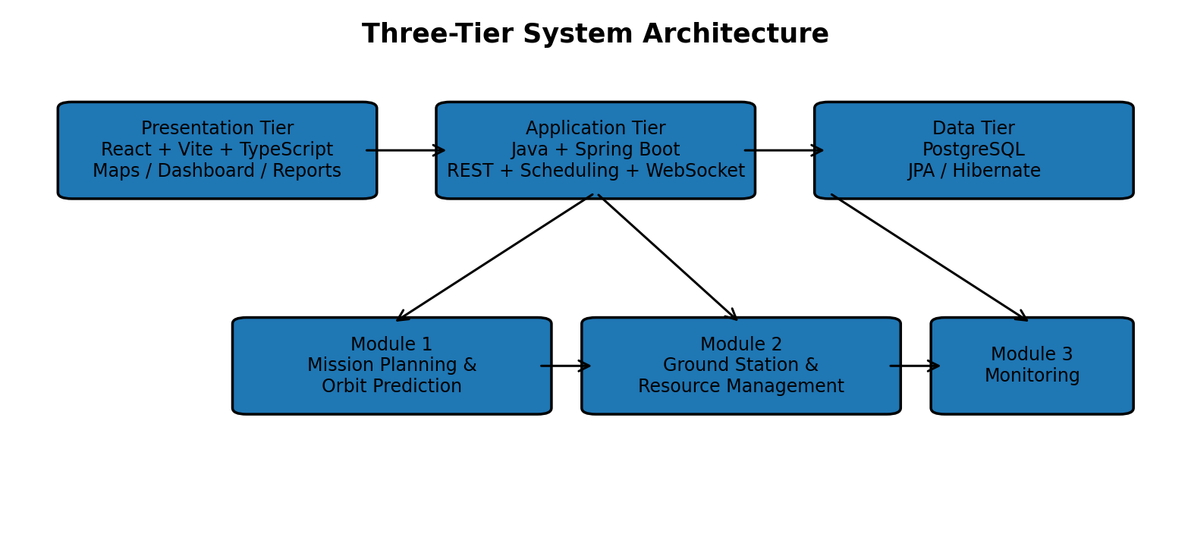
Figure 1. Three-Tier System Architecture
The systems approach is sequential and data-driven: Module 1 generates candidate Pass records; Module 2 checks station/antenna availability and resolves conflicts; Module 3 consumes the resolved schedule to create tracking sessions and publish telemetry and tracking events. REST APIs support registration and planning operations, while WebSocket/STOMP supports real-time events.

3.6 Trade-off Analysis
Design Decision | Alternative Considered | Benefit | Disadvantage | Final Decision & Justification
Integrated backend | Separate services | Direct data flow and simpler academic deployment. | Less independent service scaling. | Selected to keep all modules unified as documented.
Priority + interval scheduling | Advanced genetic/heuristic optimization | Deterministic and easier to demonstrate. | May not maximize global mission value. | Selected for the documented prototype; advanced optimization is future work.
Simulated telemetry | Real telemetry ingestion | Demonstrates WebSocket pipeline without spacecraft link. | Not representative of actual spacecraft telemetry. | Selected for academic demonstration.
PostgreSQL + JPA/Hibernate | Multiple data stores | Shared relational operational state. | Requires careful schema design. | Selected for unified persistence.

3.7 Sustainability, Ethics, Safety, Risk & Security
Domain | Consideration | Evidence Evaluated | Impact on Final Decision
Sustainability | Avoid unnecessary deployment complexity for the academic prototype. | Single React frontend, Spring Boot backend and PostgreSQL persistence. | Supports an integrated architecture with fewer deployment components.
Ethics | Academic integrity, accurate reporting and acknowledgement of external resources. | Declaration and reference list in the project report. | No fabricated or manipulated results are claimed.
Health & Safety | Avoid treating the prototype as operational spacecraft-control software. | Source report explicitly excludes safety-critical command uplink and production mission assurance. | Limits system scope to academic planning and monitoring.
Security | Protect schedule/resource modifications and live operational events. | Server-side authorization and WebSocket subscription validation are documented. | Security controls are included as engineering requirements.

Risk Register
Risk | Likelihood | Severity | Risk Level | Mitigation | Residual Risk
Malformed TLE / propagation error | Medium | High | High | Validate TLE input and handle propagation errors. | Medium
Incorrect AOS/LOS boundary | Medium | High | High | Use defined time step and refine elevation-crossing detection. | Medium
Conflicting bookings | Medium | High | High | Use interval overlap checks and database transactions. | Low–Medium
WebSocket disconnect | Medium | Medium | Medium | Allow client reconnection; backend continues operation. | Low
Outdated TLE data | Medium | Medium | Medium | Record TLE source/time and support future automated refresh. | Medium
Simulated telemetry misinterpreted as real | Low | High | Medium | Clearly label telemetry as simulated unless a real source is connected. | Low

CHAPTER 4: IMPLEMENTATION, TESTING & RESULTS, PROJECT MANAGEMENT

4.1 Development Approach & Resources
The development process is organized around a single integrated Spring Boot backend and a single React frontend. The backend is divided into module-aligned packages rather than separate applications. PostgreSQL provides the common persistence layer, while REST APIs handle CRUD and planning operations and WebSockets handle live events.
Resource | Purpose
Java + Spring Boot | Backend controllers, services, business logic and scheduling.
React + Vite + TypeScript | Frontend dashboard, forms, maps, charts and operator views.
PostgreSQL + JPA/Hibernate | Persistent missions, satellites, passes, stations, availability and logs.
Spring WebSocket / STOMP | Live pass and telemetry updates.
Java SGP4/SDP4 implementation/library | TLE-based orbit propagation and pass prediction.
Maven + npm | Backend and frontend build/dependency management.

4.2 Software Implementation & Modern Tools Used
Tool / Software | Purpose | Stage Used
Java / Spring Boot | REST controllers, services, scheduling and backend integration. | Implementation
React / Vite / TypeScript | Dashboard and operator views. | Implementation
PostgreSQL / JPA / Hibernate | Shared persistent data model. | Implementation
Leaflet.js or Cesium.js | Ground-track, station and polar visualization. | Visualization
Spring WebSocket / STOMP | Real-time tracking and telemetry. | Monitoring
Maven / npm | Dependency and build management. | Build / Deployment

Table 9. Implementation Tools and Purpose
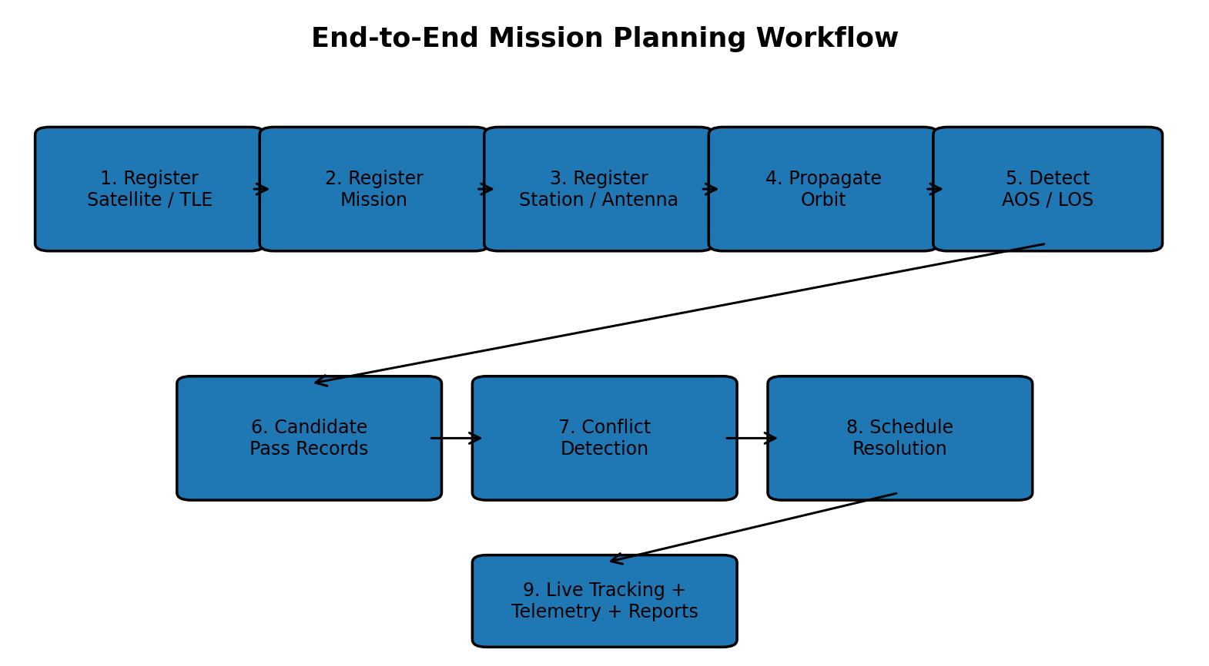
Figure 2. End-to-End Mission Planning Workflow

4.3 Test Plan & Verification
Requirement | Test Method | Acceptance Criterion
TLE registration | Submit valid and malformed TLE inputs. | Valid input accepted; invalid input reports an error.
Pass prediction | Run propagation for a registered satellite and station. | AOS/LOS and positive-duration pass candidates are produced when visible.
Conflict detection | Submit overlapping pass requests for the same resource. | ConflictLog entry is created.
Conflict resolution | Use conflicting missions with different priorities. | Higher-priority mission is retained according to policy.
Maintenance constraint | Overlap a pass with station maintenance. | Booking is rejected or moved.
Real-time tracking | Activate a resolved pass. | TrackingSession becomes active and dashboard updates.
Telemetry stream | Run an active session. | Battery, signal and temperature events are pushed.
WebSocket loss | Disconnect a client. | Backend continues operation and client can reconnect.
Report query | Query a completed period. | Utilization/success statistics are returned.

4.4 Results
The intended end-to-end result is a single application in which an operator can register a satellite and mission, generate predicted visibility windows, send those windows into ground-station scheduling, resolve resource conflicts, and observe the selected pass through the live monitoring dashboard.
Result Area | Documented Result
Pass prediction | Pass records containing AOS, LOS, duration and visibility information.
Ground-station management | Availability and booking state.
Conflict management | Conflict records and documented resolution actions.
Scheduling | Resolved schedule available to monitoring.
Real-time monitoring | Tracking events delivered through WebSockets.
Telemetry | Simulated battery, signal and temperature stream.
Visualization | Ground-track and polar-plot views.
Reporting | Station-utilization and mission-performance reports.
Alerts | Conflict and missed-pass alerts.
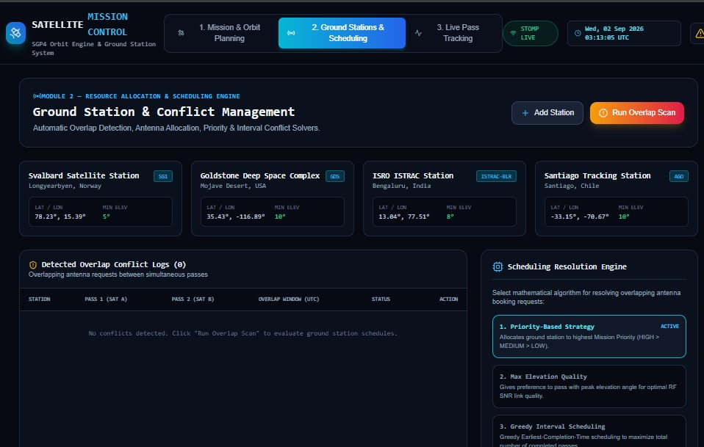

4.5 Data Analysis & Engineering Judgment
Orbit prediction accuracy depends on the quality and age of the supplied TLE and on the correctness of the propagation and coordinate-conversion implementation. The report recommends recording TLE source/time and using a defined propagation time step. Pass-boundary detection can be refined around the elevation crossing rather than relying only on a coarse sample interval.
Scheduling performance depends on the number of candidate passes and resources. A practical implementation should first filter candidates by station and time interval, then apply conflict detection only to relevant overlapping windows. The monitoring layer should use event-driven WebSocket updates instead of repeatedly polling the backend for every telemetry value.

4.6 Comparison with Existing Solutions & Achievement of Objectives
Objective | Evidence | Achievement
Accurate visibility calculation | TLE + SGP4/SDP4 pass-prediction workflow documented. | Fully demonstrated at prototype level
Ground-station/resource management | Station, antenna and availability entities and services documented. | Fully demonstrated at prototype level
Conflict resolution | Overlap test and priority/interval scheduling documented. | Fully demonstrated at prototype level
Real-time monitoring | TrackingSession, WebSocket/STOMP and telemetry flow documented. | Fully demonstrated at prototype level
Historical reporting | Report entity and utilization/success summaries documented. | Partially demonstrated / prototype level

4.7 Strengths & Limitations
Strengths
- Integrates orbit prediction, scheduling and monitoring into one workflow.
- Uses a unified Spring Boot backend and PostgreSQL persistence layer.
- Applies deterministic conflict detection and priority-based scheduling.
- Supports real-time tracking and telemetry demonstration using WebSockets/STOMP.
- Separates modules clearly while maintaining shared integration contracts.
Limitations
- Telemetry is simulated rather than sourced from an actual spacecraft.
- Propagation accuracy depends on the quality and age of TLE data.
- Advanced optimization objectives are not implemented in the documented prototype.
- Operational mission assurance, certified flight dynamics and safety-critical command uplink are outside scope.
- The source report recommends stronger authentication, audit trails, automated TLE refresh and production deployment as future work.

4.8 Project Planning, Roles & Budget
Student | Assigned Responsibility | Actual Contribution
P. Venkata Sai Pradeep Reddy | Team development and module integration | Development, integration, testing and documentation as recorded in the project report.
B. Hemanth Kumar | Project demonstration and presentation support | Demonstration, verification and report/presentation contribution.
A. Vamsi | Ground-station/resource and monitoring support | Scheduling/monitoring integration, testing and documentation.

Table 10. Project Roles and Contribution
Milestone | Work Package | Outcome
1 | Requirement and problem analysis | Problem statement, objectives and scope.
2 | Architecture and data design | Three-tier architecture and core entities.
3 | Module implementation | Orbit prediction, resource management and monitoring components.
4 | Integration | REST and WebSocket data flow.
5 | Testing and validation | Functional test cases and conflict scenarios.
6 | Documentation and demonstration | Final report and capstone presentation.

Item | Estimated Cost | Actual Cost
Software / development tools | Academic / open-source resources | Academic / open-source resources
Database | PostgreSQL | PostgreSQL
Hardware | No dedicated hardware documented | No dedicated hardware documented
Total | Not specified in source report | Not specified in source report

CHAPTER 5: CONCLUSION, FUTURE WORK AND REFLECTION

5.1 Conclusion
The Satellite Mission Planning & Ground Station Management System demonstrates an integrated approach to satellite pass prediction, ground-station scheduling, and real-time mission monitoring. The project addresses the practical difficulty created by short visibility windows and competition among multiple satellites for limited station resources.
Module 1 uses TLE-based SGP4/SDP4 propagation to generate satellite visibility information and Pass records. Module 2 consumes those records, checks resource availability, detects overlaps, and applies scheduling logic to resolve conflicts. Module 3 consumes the resolved schedule and provides real-time tracking, simulated telemetry, visualization, alerts, and reporting through an operator dashboard.
The three-tier implementation architecture—React frontend, Spring Boot backend, and PostgreSQL database—keeps the application unified while allowing the three functional modules to remain clearly separated at the service/controller level. WebSockets provide the real-time communication required for active-pass monitoring, while REST APIs support registration and planning operations.
The main contribution of the project is therefore not a single algorithm or interface, but the integration of orbital mechanics, resource scheduling, persistent data management, and event-driven monitoring into one coherent workflow.

5.2 Future Work
- Support automated TLE refresh from an authoritative orbital-data source.
- Add more advanced scheduling objectives such as maximizing mission value or station utilization.
- Support multiple antennas and simultaneous frequency-band constraints.
- Add authentication, role-based access and audit trails.
- Replace simulated telemetry with a real telemetry ingestion interface.
- Add email/mobile notifications for critical missed-pass events.
- Introduce deployment using Docker and a production PostgreSQL instance.
- Add automated integration tests for propagation, scheduling and WebSocket event flows.

5.3 Professional Learning & Individual Reflection

New Knowledge Acquired
- Orbital-data processing and SGP4/SDP4 propagation concepts.
- Ground-station visibility and AOS/LOS calculations.
- Conflict detection and interval-scheduling concepts.
- Java Spring Boot, REST APIs and JPA/Hibernate.
- React + TypeScript frontend integration.
- WebSocket/STOMP real-time communication.

Engineering & Professional Skills Developed
- System-level thinking across multiple interacting modules.
- API and data-contract design.
- Database modelling and transaction-aware scheduling.
- Testing, debugging and technical documentation.
- Technical presentation and project demonstration.

Individual Reflection – P. Venkata Sai Pradeep Reddy
The project required understanding how orbit prediction and scheduling interact rather than treating them as separate functions. A key learning area was integrating the backend services and maintaining a clear data flow between modules. The experience strengthened practical Java and full-stack development skills and highlighted the importance of systematic testing.

Individual Reflection – B. Hemanth Kumar
A major responsibility was the project demonstration and presentation of the integrated capstone workflow. Preparing the demonstration required understanding how the modules connect and how the final system behaviour should be explained clearly. The experience improved confidence in technical communication, verification of the workflow, and presenting an engineering solution in a structured manner.

Individual Reflection – A. Vamsi
The project provided practical exposure to the relationship between ground-station resource management, scheduling conflicts and monitoring. Working with the integrated workflow highlighted the importance of consistent interfaces between modules. The experience strengthened problem-solving, testing and technical documentation skills.

5.4 Overall Reflection
Overall, the project improves confidence in developing integrated full-stack systems rather than isolated programs. It combines Java backend engineering with frontend visualization, relational data management, algorithmic scheduling, orbital computation, and real-time communication. The experience also reinforces the importance of documenting assumptions and validating each interface between modules.

REFERENCES
[1] R. Wang, J. Liu, and Q. M. Zhang, “Propagation errors analysis of TLE data,” Advances in Space Research, vol. 43, no. 7, pp. 1065–1069, 2009. DOI: 10.1016/j.asr.2008.11.017.
[2] J. F. San-Juan, I. Pérez, M. San-Martín, and E. P. Vergara, “Hybrid SGP4 orbit propagator,” Acta Astronautica, vol. 137, pp. 254–260, 2017.
[3] L. Barbulescu, J.-P. Watson, L. D. Whitley, and A. E. Howe, “Scheduling Space–Ground Communications for the Air Force Satellite Control Network,” Journal of Scheduling, vol. 7, pp. 7–34, 2004.
[4] F. Marinelli, S. Nocella, F. Rossi, and S. Smriglio, “A Lagrangian heuristic for satellite range scheduling with resource constraints,” Computers & Operations Research, vol. 38, no. 11, pp. 1572–1583, 2011.
[5] B. Sun, “Satellite mission scheduling based on genetic algorithm,” Kybernetes, vol. 39, no. 8, pp. 1255–1261, 2010.
[6] L. Yuqing, R. Wang, and M. Xu, “Satellite range scheduling with the priority constraint: An improved genetic algorithm using a station ID encoding method,” Chinese Journal of Aeronautics, vol. 28, no. 3, pp. 789–803, 2015.
[7] K. Luo et al., “High-performance technique for satellite range scheduling,” Computers & Operations Research, vol. 85, pp. 12–21, 2017.
[8] S. Spangelo, J. Cutler, and K. Gilson, “Optimization-based scheduling for the single-satellite, multi-ground station communication problem,” Computers & Operations Research, vol. 57, pp. 1–16, 2015.
[9] A. S. Eshetu and H.-D. Kim, “A New Strategy of Visibility Conflict Optimization Between Multiple Ground Stations and Satellites,” International Journal of Aeronautical and Space Sciences, vol. 23, no. 5, pp. 1009–1020, 2022.
[10] X. Xu et al., “A Hybrid Genetic Algorithm for Ground Station Scheduling Problems,” Applied Sciences, vol. 14, no. 12, 5045, 2024.

APPENDICES

Appendix A – Detailed End-to-End Workflow
- Register satellite and enter TLE data.
- Register mission objective, priority and frequency.
- Register ground station and antenna resources.
- Select satellite and ground station for prediction.
- Run SGP4/SDP4 propagation for the requested time range.
- Calculate satellite elevation and azimuth relative to the station.
- Detect AOS and LOS and create Pass records.
- Send candidate passes to the scheduling service.
- Check station/antenna availability and overlapping requests.
- Apply priority and interval-scheduling rules.
- Persist the resolved schedule and conflict log.
- Activate TrackingSession when a scheduled pass begins.
- Broadcast tracking and simulated telemetry over WebSockets.
- Display ground track, polar plot, telemetry and alerts.
- Generate historical mission/station reports.

Appendix B – Proposed Dashboard
Dashboard Area | Information Displayed
Mission Planning | Satellite/TLE registration, mission details, station selection, predicted pass table.
Ground Station Management | Station location, antenna capability, availability, bookings and conflicts.
Live Monitoring | Active satellite, AOS/LOS, countdown, ground track, polar plot and tracking state.
Telemetry | Battery, signal and temperature with timestamped updates.
Alerts | Conflict, missed-pass and operational warning messages.
Reports | Mission success rate, completed/missed passes and station utilization.

Appendix C – Suggested API / Data Flow
A representative integrated request sequence is: POST satellite → POST mission → POST station/antenna → POST pass-prediction request → GET candidate passes → POST schedule request → GET conflicts/resolution → WebSocket subscription → active tracking events → telemetry events → GET report.

Appendix D – Suggested Database Relationships
- Satellite 1:N Mission
- Satellite 1:N OrbitData
- Satellite 1:N Pass
- GroundStation 1:N Antenna
- GroundStation 1:N Availability
- Pass N:1 GroundStation
- Pass 1:N TrackingSession (as permitted by implementation)
- TrackingSession 1:N TelemetryLog
- Pass/TrackingSession 1:N Alert
- GroundStation/Mission/Pass data contribute to Report generation

Appendix E – Project Module Mapping
Module | Primary Backend Packages | Primary Frontend View
Module 1 | mission.controller / mission.service / orbit.service / mission.repository | Mission Planning & Pass Prediction
Module 2 | station.controller / station.service / scheduling.service / station.repository | Ground Station & Conflict Management
Module 3 | monitoring.controller / tracking.service / telemetry.service / report.service | Live Tracking & Reports

Appendix F – Capstone Project Outcome Mapping Sheet
Outcome / Area | SO / Area | Location in This Report
Complex engineering problem formulation | SO1 | Chapter 1 and Chapter 2
Engineering design under constraints | SO2 | Chapter 3
Written/oral technical communication | SO3 | Whole report and demonstration
Ethics and professional responsibility | SO4 | Chapter 3.7
Teamwork and leadership | SO5 | Chapter 4.8
Experimentation, analysis and engineering judgment | SO6 | Chapter 4.3–4.6
Independent acquisition of new knowledge | SO7 | Chapter 5.3
Standards | SO2 | Chapter 3.2
Sustainability and societal/environmental impact | SO2/SO4 | Chapter 3.7
Risk assessment and mitigation | SO2/SO4 | Chapter 3.7
Security considerations | Relevant SO | Chapter 3.7
Integrated/system-level engineering | SO1/SO2 | Chapter 3.5
Project planning and management | SO5 | Chapter 4.8
Individual contribution | SO1–SO7 | Contribution Statement and Chapter 4.8

